OAC e-filing System Public User Guide

Welcome to OAC’s e-filing system, the Office of Administrative Courts’ new integrated case management and electronic filing system.
If this is your first time using e-filing, you can get started by going to the public forms page and submit a case initiation form (WC – An Application for Hearing or for GS – Case Initiation Form).

You will be required to create an account. Your Community user account will allow you access to additional features, including the ability to view and download documents in your case. When your form is submitted, you will receive an e-mail (as provided in the submission of the form) when the submission is received and also when the submission is approved by a clerk.
If you already have a case before the OAC and you would like to access OAC e-filing, send an e-mail to OAC-GS@state.co.us with OAC e-filing Account in the subject line. Make sure to include your name, address, telephone number, attorney number and e-mail (the e-mail address that you want to receive notifications from the OAC) as well as the case number of any case you are already a party to.
When your account has been created, you will receive an e-mail with a link for you to set up your password for OAC e-filing.
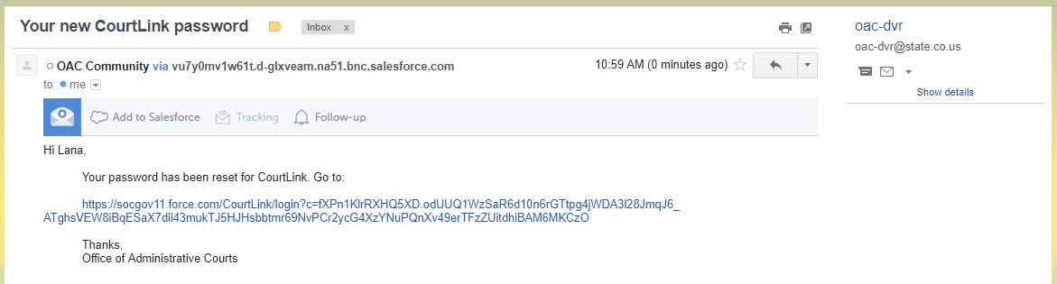

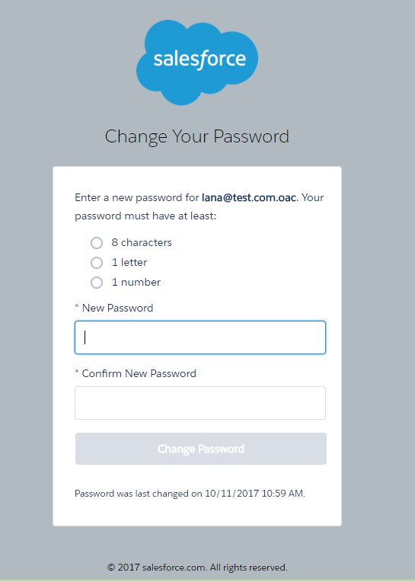

When you land on the home page, you will see:
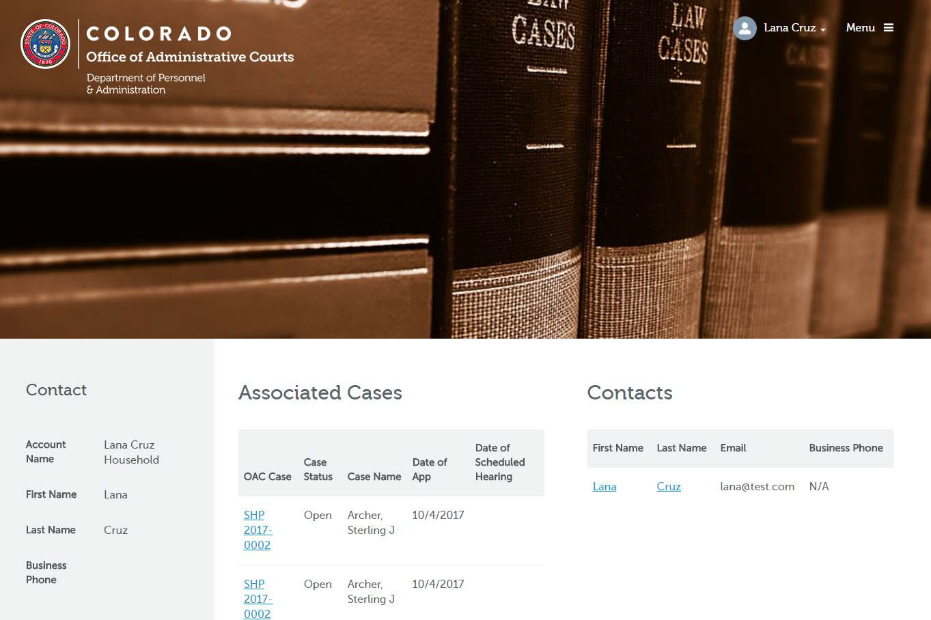

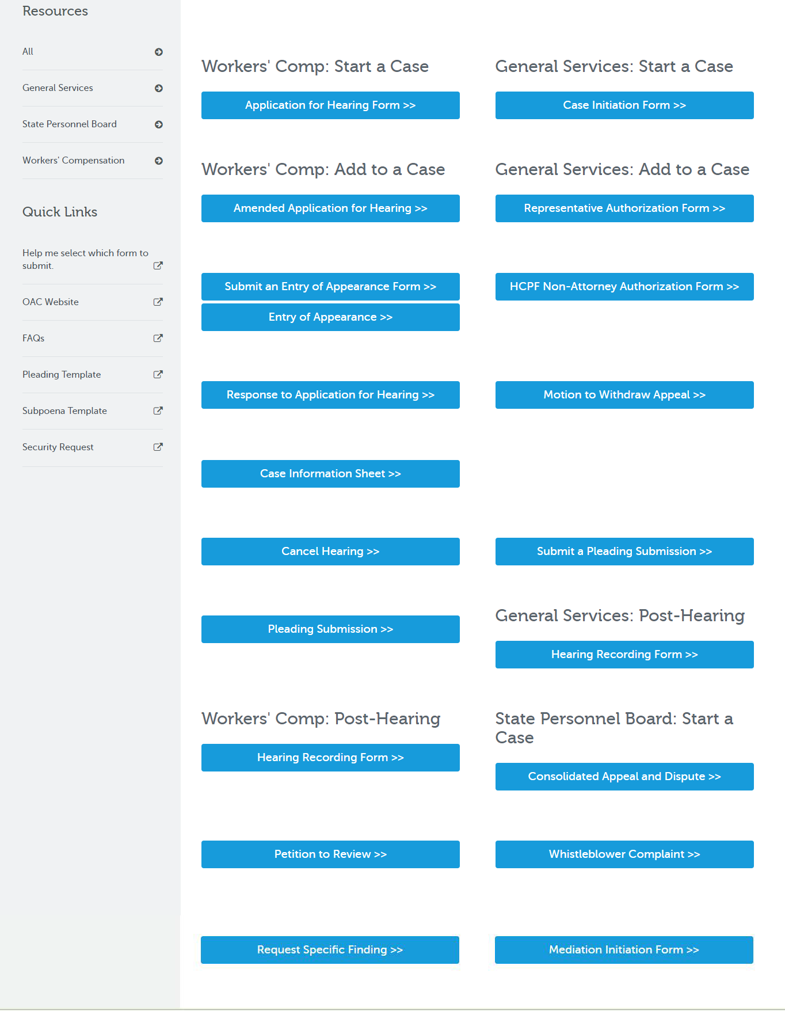

You can access cases you are associated with: The information you will see includes the date the initiating pleading was received, the names, e-mails and phone numbers of case parties as well as Pleadings, and scheduled hearing and conferences.

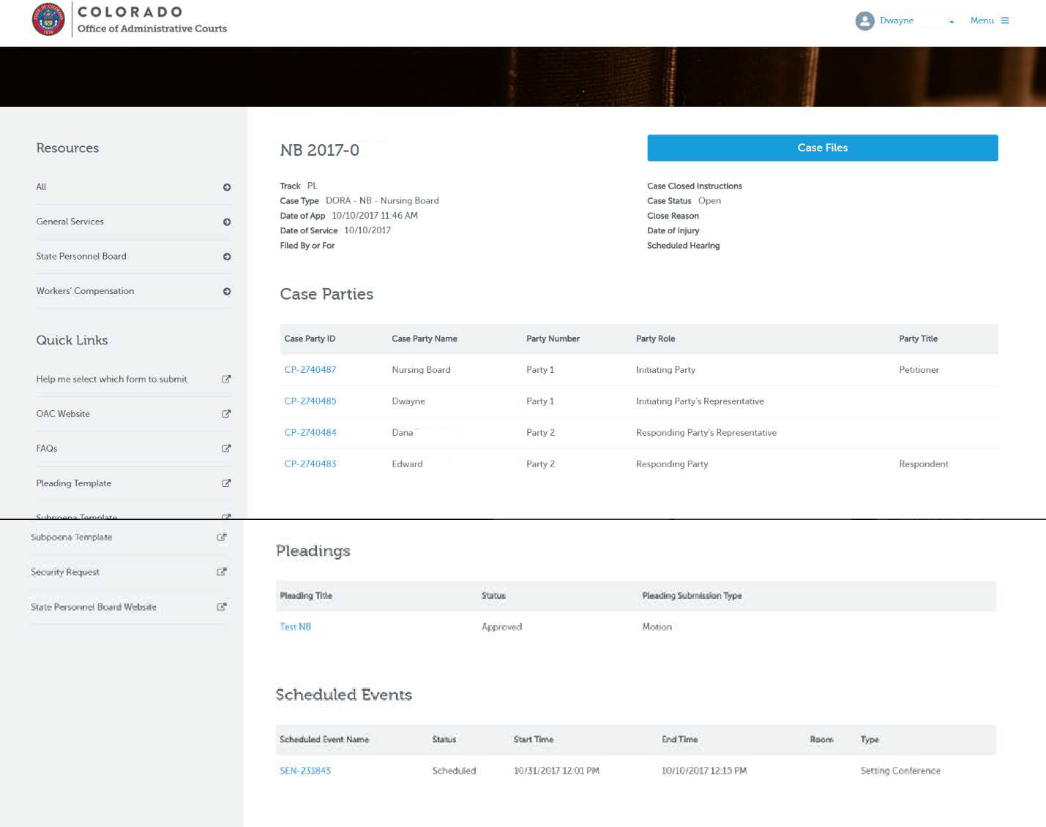

By clicking Case Files, you can also access documents pertaining to the case:

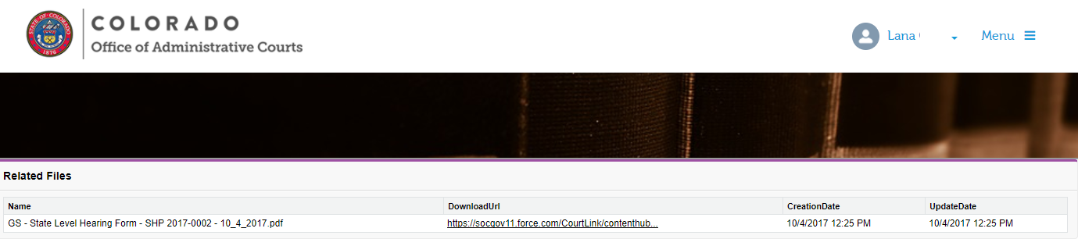
A list of documents in the case will then be displayed. Click on the link in the DownloadUrl column to download the document.

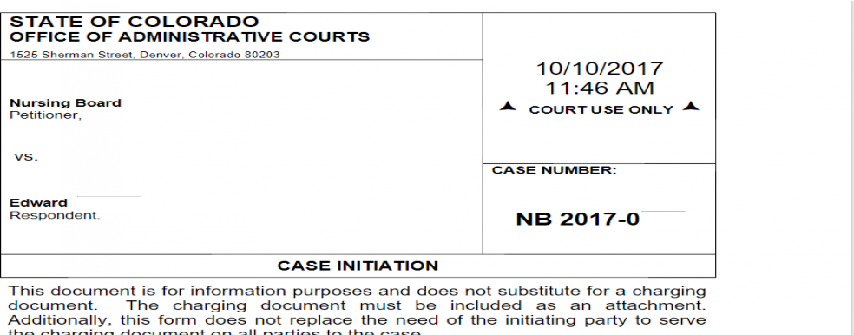

On the left margin, you will find instructions for completing forms under Resources as well as links to forms and information from the OAC website.

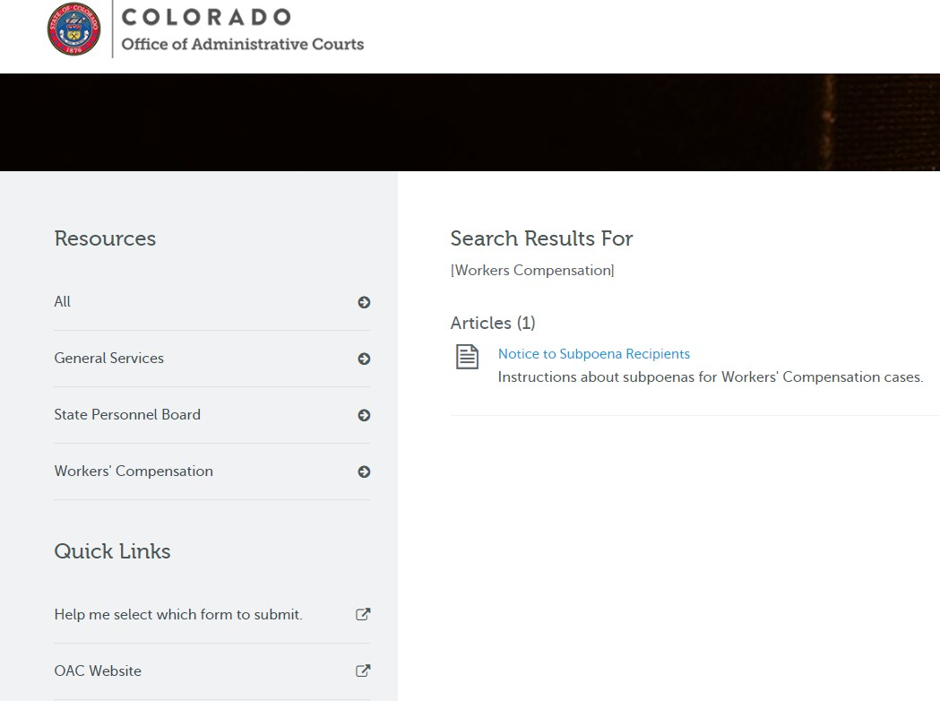

For additional assistance, contact the OAC.

Workers’ Compensation Docket: 303-866-5881 or oac-dvr@state.co.us

All non Workers’ Compensation questions should be directed to General Services Docket: 303-866-5626 or oac-gs@state.co.us .

